

Jaiku Mobile

v0.83
For Nokia S60 3rd Edition Devices

User’s Guide

27 July 2009

Table of contents
Welcome to Jaiku Mobile! This guide will help you to obtain, install, and use Jaiku Mobile on your Nokia S60 3rd Edition mobile device.
The guide contains the following sections:
1. Obtaining Jaiku Mobile for your phone 4
1.1 Compatible handsets 4
1.2 Transferring Jaiku Mobile from your computer to your phone over Bluetooth 5
1.3 Transferring Jaiku Mobile from your Windows computer to your phone over USB 11
2. Installing Jaiku Mobile 13
2.1 Installation 13
2.2 Setup Wizard 15
3. Using Jaiku Mobile 23
3.1 Starting Jaiku for the first time 23
3.2 Contact List 23
3.3 Overview Tab 27
3.4 Personal Stream 28
3.5 Status Details 28
3.6 Contact Information 32
3.7 Connectivity and Auto-Start 32
3.8 Roaming 34
3.9 Settings 34
3.10 Battery life 35
3.11 Uninstalling Jaiku Mobile 36
4. Adding Jaiku to Shortcuts (optional) 37
5. Troubleshooting 39

Obtaining Jaiku Mobile for your phone
If Jaiku Mobile is not preinstalled on your phone, you can obtain the software by signing up at www.jaiku.com
Follow the instructions on the Web to download Jaiku Mobile wirelessly to your handset.

Compatible handsets
Jaiku Mobile is compatible with the Nokia S60 operating system software versions 3.0, 3.1 and 3.2. Jaiku Mobile is not compatible with S60 5.0 (5th edition).

Transferring Jaiku Mobile from your computer to your phone over Bluetooth
If you are transferring Jaiku Mobile to your phone from a Mac or PC, follow the instructions below.

Mac OSX Users
Note: Before starting the file transfer, make sure your Mac is equipped with a Bluetooth wireless card and that Bluetooth is switched on in your phone.
- On your Mac, navigate to System Preferences -> Bluetooth Settings and make sure Bluetooth Power is turned “On” and the option “Show Bluetooth status in the menu bar” is checked
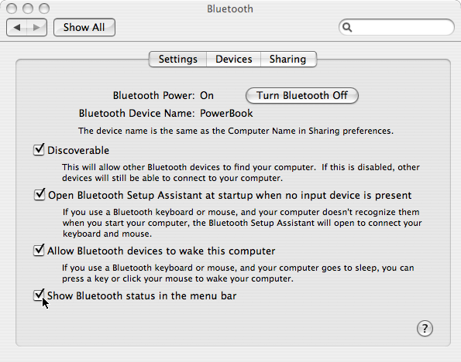
- Open the Bluetooth pulldown menu in Finder and select “Send File…”
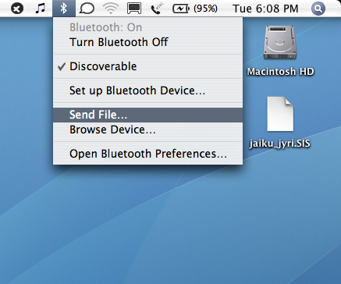
- A window titled “Select File to Send” opens. Select the Jaiku application you downloaded from www.jaiku.com
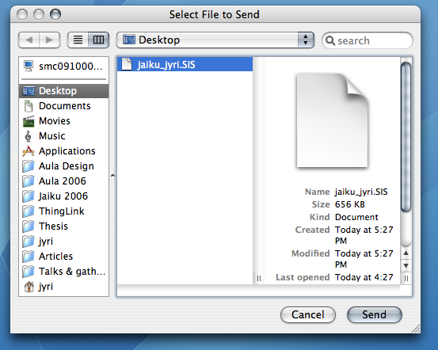
- The “Send File:” window opens. In the “Device Type” pulldown menu, choose “Phones” and click “Search”. Wait for your phone to appear in the Device list and click to select it. Then click “Send”.
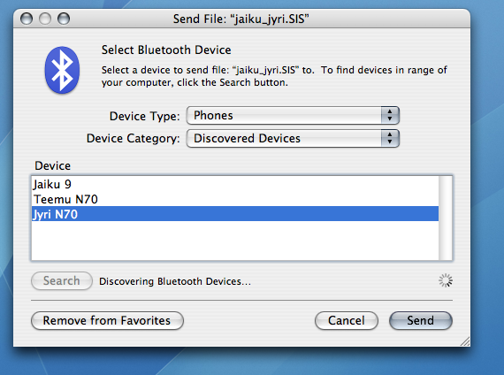
- File transfer begins. Wait for it to finish and pick up your phone.
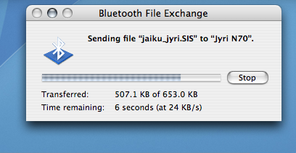
- On your phone, a prompt may appear requiring you to authorize the file transfer. Click “Yes” to receive the file. (This step is skipped if you have set you computer as a trusted device in the phone’s Bluetooth settings)
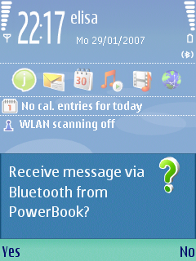
- A New Message Received indicates the file transfer is complete. Open the message to begin the installation process.
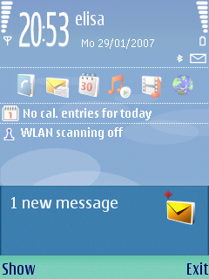

Windows Users
- Locate the Jaiku Mobile .SIS file on your computer and right-click the file icon. Select Send To -> Bluetooth and your phone if it is displayed in the list. If your phone is not displayed in the list, select “Other…”
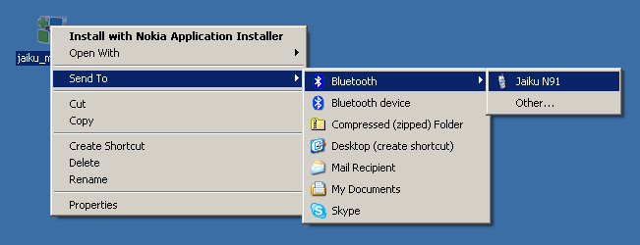
- If you selected “Other…” in the previous step, a window titled “Select Device” appears. Select your phone in the list and click “OK”.
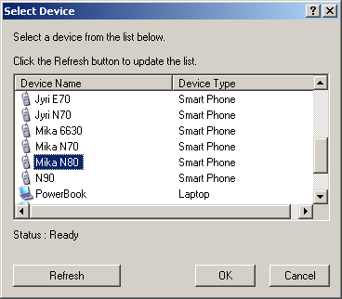
- Bluetooth file transfer begins. Wait for it to finish and pick up your phone.
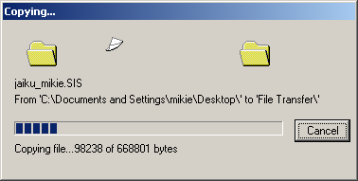
Note: If you haven’t previously “paired” your computer as a trusted device with your phone, you may be required to set an arbitrary 4-digit passkey on your phone and re-type it on the computer to authenticate the file transfer.
- On your phone, a prompt may appear requiring you to authorize the file transfer. Click “Yes” to receive the file. (This step is skipped if you have set you computer as a trusted device in the phone’s Bluetooth settings)
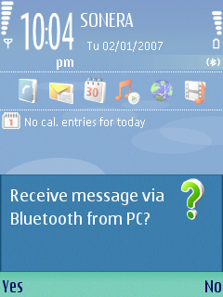
- A New Message Received indicates the file transfer is complete. Open the message to begin the installation process.
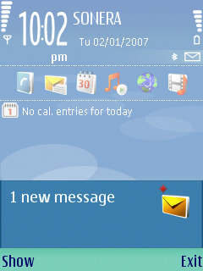

Linux Users
On Linux you can install the app over Bluetooth in two ways:
- In Ubuntu, right click the .SIS file, select "Send to..." and select your phone from the dialog.
- From the command line, with obexftp installed, you can do:
`obexftp -b -p .SIS`
You can get your handset's Bluetooth MAC address with `hcitool scan` (make sure your phone Bluetooth is switched on and set to ‘discoverable’).

1.3 Transferring Jaiku Mobile from your Windows computer to your phone over USB
Windows users: If your computer is not equipped with Bluetooth, it is possible to transfer the Jaiku application you downloaded from www.jaiku.com to your phone over USB using Nokia PC Suite® software. Nokia PC Suite® is provided with your phone’s sales package. It is also available for free download from www.nokia.com

Installing Jaiku Mobile

Installation
To ensure best possible performance, Jaiku will be installed to the phone memory.
Note: Some applications can be installed to external memory cards, which have been designed for storing images and other data. Memory cards are significantly slower to write data to than the phone’s internal memory, and running Jaiku Mobile from a memory card would degrade application performance. It is therefore not possible to install Jaiku Mobile to an external memory card.
    - When installation begins, a prompt first appears requiring you to confirm installation. Select “Yes” to continue.
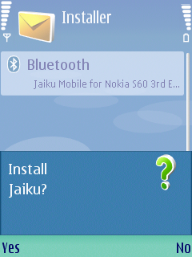
Note: If you are upgrading a previous version of Jaiku Mobile that is currently running in the background on your handset, a warning will be displayed: “Warning: Unable to install. Some applications must be closed first.” Select Continue to allow the installer to close Jaiku Mobile automatically and continue the installation process.
    - A window titled “Details” appears. It displays the name the version number of the Jaiku application. After viewing the information, select “Continue”.
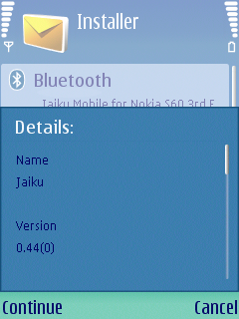
    - Installation begins. Wait for the process to finish. The Setup Wizard will launch automatically after the installation has been completed.
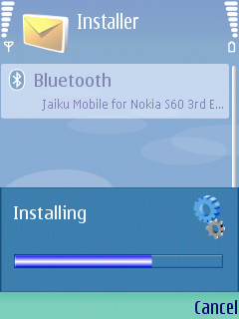
Note: The following applications will be installed
      - Jaiku in folder “Installed” (ESeries devices) / “My Own” (NSeries devices)
      - Jaiku Tool in folder “Jaiku Support”. Jaiku Tool contains a handy set of troubleshooting features (see more under Troubleshooting)

Setup Wizard
    - After installation has been completed, a message titled “Please be aware” appears. The message describes the phone functionalities Jaiku Mobile will accesss when it is running. Read the message carefully and select “Accept” to start the Setup Wizard.
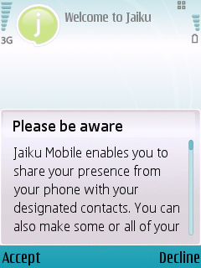
    - A “Welcome to Jaiku” message appears. Select “Continue” to begin the setup process.

    - Internet: A prompt appears asking if you are ready to connect to the Internet. Select “Yes” to continue.
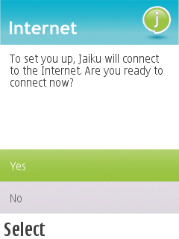
Note: Selecting “Yes” will allow Jaiku Mobile to open a network data connection.
    - A prompt appears requiring you to enter your Jaiku screen name. Type in your screen name and select “OK”
Note: If you are upgrading from a previous version of Jaiku Mobile this step will be skipped.
Note: your Jaiku screen name is defined when you sign up to Jaiku. If you can’t remember your screen name, sign in to Jaiku using your email address at www.jaiku.com and check your screen name from the top right corner of the Web page, where a text reads “Signed in as [your screen name]”.
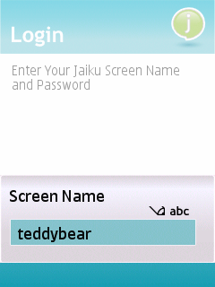
    - A password prompt appears. Enter your Jaiku password and select “OK” to continue.
Note: If you are upgrading from a previous version of Jaiku Mobile this step will be skipped.
Note: if you can’t remember your password, you can recover it at www.jaiku.com.
    - Calendar: Jaiku enables you to share your calendar with your contacts. Choose the option that best suits your needs:
      - Show title of event: Your contacts will see the title, start time, and end time of your current and next calendar event in your Presence
      - Show only “Busy”: Your contacts will see “Busy” instead of the title of the event. Useful if you want to let your friends know when you are available, but want to keep your calendar events private.
      - Do not share my calendar: Your calendar events will not be shared.
Note: You can control who can view your presence under Settings: Privacy at www.jaiku.com.
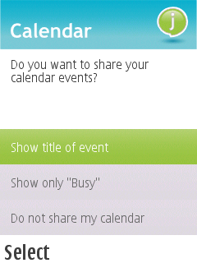

    - People Nearby: Jaiku enables you to display nearby people as part of your Presence. You can show the number of your Jaiku contacts and other people nearby based on mobile phones that have Bluetooth switched on.
Note: Displaying people nearby requires that Blueooth is switched “On” on your phone.
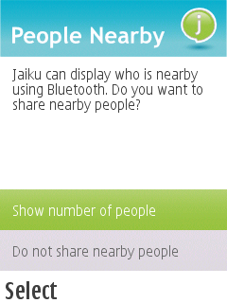
    - Battery Usage: Select if you would like to run Jaiku in Better battery life or More up-to-date mode.
In Better Battery Life mode, Jaiku will conserve battery by disconnecting from the network soon after you switch to another application or the phone is left idle. The connection will be re-opened when you switch back to Jaiku.
In more up-to-date mode Jaiku will stay connected so your status will always be up to date.
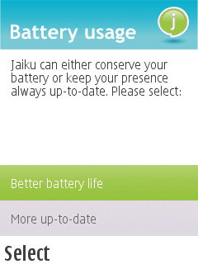

    - Access Point: If Jaiku has not been able to automatically select an access point for accessing the Internet, you will be prompted to select the access point manually.
Note: This step is skipped if the access point has been automatically selected
Note: If you are uncertain about which access point to select, contact your operator for instructions. (Hint: some operators name the access point “internet”)
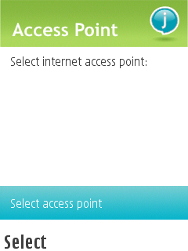
    - Auto-Start: Jaiku can start up automatically in the background when the phone is switched on. This is handy for sharing your presence without having to manually launch Jaiku.
Note: You can easily tell if Jaiku Mobile is active in the background from the Jaiku status icon displayed on the phone’s standby screen. For more information about running Jaiku in the background, see Connectivity and Auto-Start
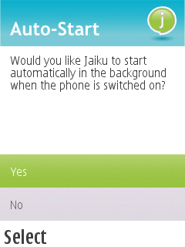
    - Finish: That’s it! Jaiku setup is now complete and you are ready to start using Jaiku.
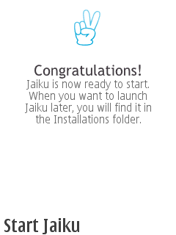

Using Jaiku Mobile

Starting Jaiku for the first time
When Jaiku Mobile starts for the first time, your live contacts will be downloaded from www.jaiku.com and matched to your phonebook.
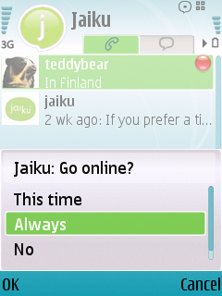

Contact List
The Contact list is the basic view on Jaiku Mobile. It displays the contacts stored on your phone. Jaiku adds presence information for those contacts who are on the Jaiku service.
The list is ordered as follows:
      - First contact: You
      - Second: Your Jaiku contacts in alphabetical order
      - Third: Your other contacts in alphabetical order
Note: People who you have added as your contacts on Jaiku, but for whom there are no contact details in your phonebook, are listed in the list but you are required to add their contact details before it is possible to call or message them.
NOTE! Changes to contacts in Jaiku affect the built-in phonebook

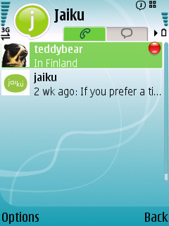
Connection status indicator
Availability indicator
Latest post and current location
Buddy icon
Contact name
Tabs
The Options menu contains the following entries. The functions accessed from the Options menu will be discussed in the sections below.
      - Go Online (If Jaiku is online)
      - New Post
      - Open
      - Call
      - Send Message
      - New Contact
      - Delete
      - Send
      - Mark/Unmark
      - Go Online (“Go Offline” if Jaiku is online)
      - Settings
      - Show Connection Error (displayed only if connection has failed)
      - Exit

Finding a contact in the list
To search for a contact, use the keypad to type in the first letters of the contact’s name. A search field will appear and matching contacts will be listed.

Making calls
To make a call, move the focus to the desired contact in the list and press the green receiver button.
Note: You can also select “Call” from Options

Sending messages
To send a message, move the focus to the desired contact in the list and select Options > Send Message

Matching your Jaiku contacts to your phonebook contacts
Jaiku automatically matches your Jaiku contacts to contacts in your phone. Jaiku uses the phone number that the contact has verified on www.jaiku.com as the basis for the matching.
If Jaiku is unable to find a match for a Jaiku contact in your phone, the name and presence information of the Jaiku contact is still displayed normally in the contact list. However, Jaiku will ask you to define a contact card for the person in your phone if you attempt to call the contact, send them a message, or view their contact details.
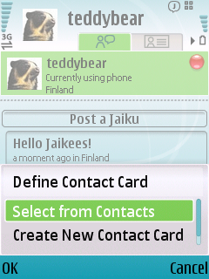

Activating the presence of a contact
Jaiku automatically activates the presence of your contacts on your phone when you add them to your list of Jaiku contacts on www.jaiku.com
If you accidentally delete a Jaiku contact on your phone and wish to re-activate them, select the contact in the Contacts list to open the contact’s Details view. In the Details view, select Options -> Activate Presence and enter the Jaiku screen name of the contact.
Note: To be able to view the contact’s presence, their lifestream must be public or they must have added you as their contact.

Adding and deleting contacts
To add a contact, select Options > New Contact
To delete a contact, select Options > Delete
If you accidentally deleted a contact and want to add them again, create a new contact with their contact details and activate the rich presence for the contact manually.

Inviting your contacts to Jaiku
Jaiku enables you to invite your contacts to join Jaiku by texting them an invitation message right from the contacts list.
To invite a contact to Jaiku, follow these steps:
1) Select the contact you wish to invite in the contacts list. The Details view opens
Note: It is not possible to send an invitation to a “live” contact whose presence has already been activated in the contacts list.
2) In the Details view, select Options > Invite to Jaiku. A new text message to the contact opens with an invitation link already included in the message
3) Write a custom introduction to your contact (optional) and send the message. You will receive an email notification when your contact has accepted the invitation
Note: You can also invite contacts to Jaiku by email from www.jaiku.com

Overview Tab
To switch from the contact list to the Overview, press the rocker right. The highlighted tab switches from the phone to the speech bubble, and the scroll area changes to display a list of the latest Jaikus and photos from your contacts (Note: Photos cannot currently be posted on the JaikuEngine-based www.jaiku.com).
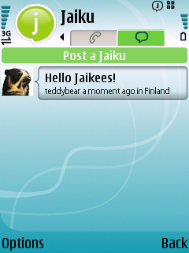
Post a Jaiku
Tabs
Latest Jaikus and photos from you and your contacts
Scroll down the list and select a Jaiku or photo to view it and add comments.

Creating a New Post
Jaiku Mobile enables you to post messages, or Jaikus, to your Stream on yourname.jaiku.com. The messages will be received by everyone who follows you.
To create a new post, select “Post a Jaiku.” A text input field will open.
Note: You can also create a new post by selecting Options > New Post in Contacts view.
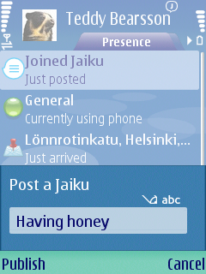
Type your message in the field provided. The topics of posts usually have to do with what you are currently doing, how you are feeling, and where you are going.
When you are finished writing your post, select “Publish” to publish it in your stream.

Personal Stream
Select yourself or one of your Jaiku contacts from the contact list to view their personal stream. Here you can see their current status and latest updates.
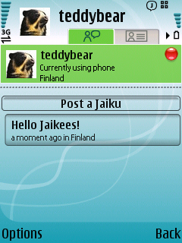
Tabs
Status
Latest updates

Status Details
If more details are available about the current status of a contact, you can view the details by selecting their status in their personal stream.
Depending on the Jaiku client application, you can share more restricted or detailed status information. Jaiku Mobile for Nokia S60 phones enables you to share your availability, location, nearby people, and calendar events.
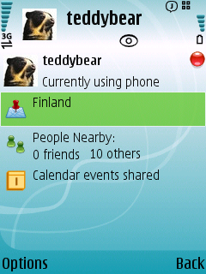
Buddy icon, screen name and status
Location
Nearby People
Calendar

Changing your Availability
Jaiku enables you to share your availability based on the ring profile of your phone. The ring profile is displayed as a traffic light next to your name in the contact list, and in the Presence view.
To change the ring profile, press the power button of your phone and select the desired profile from the menu, or navigate to Profiles from the phone menu.

Setting your Location
Jaiku automatically recognizes your location based on the cellular network tower ID using Google’s Geolocation database. Note: cellular positioning is only accurate to 500 – 5000m. The geolocation look up is not made each time you move to conserve battery but only periodically, so when you enter a new location the name may not be up-to-date immediately.
You can also set your own name for your current location.
To define your location, select your location in the Presence view. A form is displayed with fields for Neighborhood and City/Region.
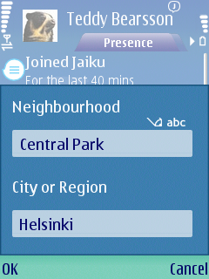

People nearby
If you have selected to share people nearby using the phone’s Bluetooth connection, the following information will be displayed:
      - Number of “Friends” whose phones are within Bluetooth range if Bluetooth is switched on in their phone
      - Number of other people nearby based on the number of other active Bluetooth phones in range
Move the focus to People Nearby and press select to change your sharing options.
Your Jaiku contacts who share their People Nearby will automatically be displayed as “friends” when they are in Bluetooth range.
Tip: To manually define a person as your friend, move the focus to People Nearby and select Options > BT Neighborhood. Select “Friends” and then Options > Add Device. Then select your friend’s phone from the list of discovered Bluetooth devices.
Note: Make sure Bluetooth is switched on in the other device before attempting to add it.

Sharing your calendar events
Jaiku enables you to share your calendar events. You can set the settings for how you want to display your calendar events by moving the focus to Calendar and pressing select.
When calendar sharing has been activated, Jaiku will display the currently active event or the next upcoming event in the Presence view.

Contact Information
To view the contact details of a contact, open the Presence view of the contact and press the rocker right to switch to the Details tab.
The Details tab functions like the one in the phone’s built-in Contacts. You can add, delete, and edit contact details and labels by accessing the functions in the Options menu (select Options > Edit).
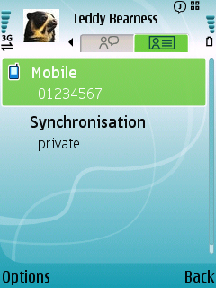

Connectivity and Auto-Start

Connecting to the Internet
Jaiku Mobile accesses the Internet using the phone’s GPRS or 3G network connection depending on your phone’s settings. Wi-Fi access points are not currently supported.
To connect to the Internet, select Options > Go Online.
Note: Jaiku Mobile is a connected application that works best when it can stay online in the background even when other applications are running. Jaiku Mobile will stay online in the background if you exit from the Contact list using the Back key.
Note: In Longer Battery Life mode Jaiku disconnects soon after you switch to another application or leave the phone idle. Jaiku will re-connect when you switch back to it.
A status icon displays the current status of Jaiku Mobile. The status icon is displayed on the Standby screen and the application title bar when Jaiku Mobile is running in the background.
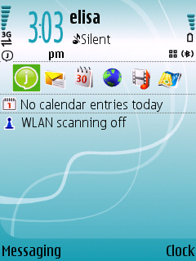
The status icon has four states:
Online
Offline
Connecting (blinking animation)
Connection failure
To disconnect Jaiku Mobile from the Internet, select Options > Go Offline. You can also disconnect by selecting Options > Exit.
Note: If the connection failure icon is displayed, the connection error message will be available from Options > Show Connection Error in the Contacts view.

Using Jaiku Mobile in offline mode
Jaiku Mobile can be used in offline mode to make calls and manage contacts. In offline mode the contacts will continue to display the status they had when Jaiku Mobile was last synchronized with the online service.

Enabling and disabling auto-start
Jaiku Mobile can be set to start automatically in the background when the phone is switched on. This is useful for sharing presence automatically without needing to launch Jaiku Mobile by hand every time the phone is switched on.
To change the auto-start preferences, go to the contacts list and select Options > Settings > Auto-Start

Monitoring the amount of data transferred
Jaiku Mobile transfers data when it updates the presence information of you and your contacts over the Internet.
To monitor the amount of data transferred, open your Presence view and select Options > Settings > Data Transferred.

Roaming
Jaiku Mobile automatically detects if your phone is roaming away from its home network. If you have set Jaiku Mobile to connect automatically to the Internet, a message will be displayed asking you if you want to stay online when roaming. If you reply “No”, Jaiku Mobile will stay offline until you return your home network.
If you have answered “No” but would like to connect at a later point while roaming, open the Contacts list and select Options > Go Online.

Settings
The following settings can be accessed by selecting Options > Settings:
      - Setup Wizard
Re-run the Setup Wizard displayed during first run
      - Jaiku Screen Name
Your screen name on www.jaiku.com
      - Jaiku Password
Your password on www.jaiku.com
Note: If you change your Jaiku password on the Web, you must manually change it on your phone. This will be fixed in later releases.
      - IP Access Point
Used to access the Internet. Check with your operator if you need to verify what is the right access point for your network.
      - Battery Life
Select Better Battery Life or More up-to-date (see below for details)
      - Download images
Select Yes to download images in Jaikus automatically, No to manually select which images to load. (Note that the JaikuEngine-based www.jaiku.com does not currently support images in Jaikus).
      - Internet Connection
Define if Jaiku is allowed to connect to the Internet automatically or prompts for permission first.
      - Auto-Start
Set Jaiku to start automatically when the phone is switched on
      - Data Transferred
View the amount of data transferred by Jaiku since installation. Also includes version number information

Battery life
You can control how much battery Jaiku uses from Settings > Battery Life. There are two options: Better Performance and Better Battery Life.
      - In More up-to-datee mode Jaiku will stay connected even when another application is active or the phone is not in use. This way your status will always be up to date.
      - In Better Battery Life mode, Jaiku will disconnect soon after you switch to another application or the phone is left idle.
Note: Running Jaiku in GSM mode will require you to charge the battery about every 2 days. 3G consumes more power, and having your phone in Dual/3G mode will cause the battery to drain more quickly. We recommend nightly charging.
Tip: Phones consume more battery in areas where network coverage is poor. Setting your phone to GSM mode will usually increase battery life especially in such areas.

Uninstalling Jaiku Mobile
To uninstall Jaiku Mobile, follow these steps:
1) Open Application Manager from the phone menu (in the Tools or Installations folder). A menu of installed applications opens
2) Move the focus to Jaiku
3) Select Options -> Remove
Note: If Jaiku is running in the background, a warning will be displayed: “Warning: Unable to remove Jaiku. Some applications must be closed first.” Select Continue to close Jaiku automatically and continue the uninstallation process
Note: Jaiku Mobile does not currently support the phone’s built-in Backup / Restore function. If you restore your phone data from a backup, you will need to re-install Jaiku Mobile manually.

Adding Jaiku to Shortcuts (optional)
The strip of applications visible when the phone is idle is known as the Standby menu. This menu can be customized from Settings. Here’s a quick reference for adding Jaiku as a shortcut to the menu.

    - Move the focus down to “Active standby apps.” and press select.
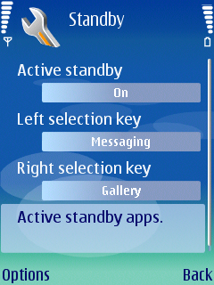
    - A list of the available shortcuts will open. Select the shortcut you wish to replace with Jaiku
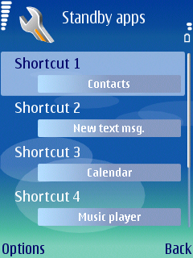
    - A menu of available applications will open. Scroll down the menu and select Jaiku.
Note: Makes sure you select “Jaiku”, not “Jaiku Tool”. The Jaiku Tool application is for troubleshooting only.
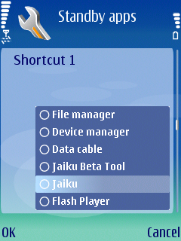
    - The application selection menu will close and you will return to the shortcut list.
Note: Jaiku is now defined as the selected shortcut.
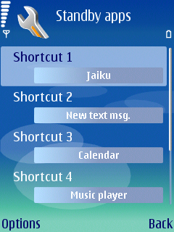
    - Press “Back” repeatedly until you return to the Standby menu.
Note: You can also return to Standby by pressing the red receiver key.
Check the Shortcuts dock. The Jaiku icon should now be displayed in the slot you selected.
    - Move the focus to Jaiku and press Select to launch Jaiku Mobile
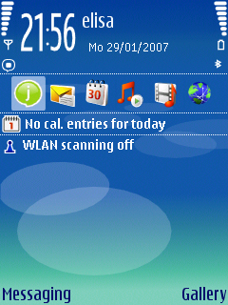

Troubleshooting
For troubleshooting purposes, a separate application named Jaiku Tool is installed in a Jaiku Support folder during installation.
Jaiku Tool is meant for use only with instructions from Jaiku Customer Support.
Jaiku Tool enables you to:
- Stop the Jaiku Service
- Stop Jaiku Contacts
- Disable automatic start
- Reset all Jaiku data
- Send logs to Jaiku customer support
- Enable debug logs
If you encounter problems using Jaiku mobile, please contact Jaiku customer support at support@jaiku.com

At least Feisty onwards

